**Lab report-2**

Name of the lab report: Basic Linux commands.

Name: Shourov Kabiraj

ID: IT-17045

***1.What is Linux?***

In the simple language Linux is an operating system (OS). We all are familiar with other operating systems like Microsoft windows, Apple Mac OS, iOS, Google android, etc, just like them linux is also an operating system.

**Basic Commands of Linux:**

1.pwd : pwd means “present working directory.”This command means "print name of the current / working directory" and takes effect when we don’t know which directory are in from the command line.

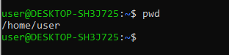

2.ls: The ls command is used to lists all the files and directories mainly.

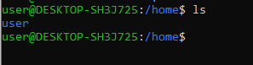

3.cd: The command “cd” means change directory and it is used to change the current directory.



4.chmod: The chmod command stands for change mode,and it's used to limit access to resources.



5.df: The 'df' command stands for “disk file system”. Linux has a strong built-in utility called 'df’.

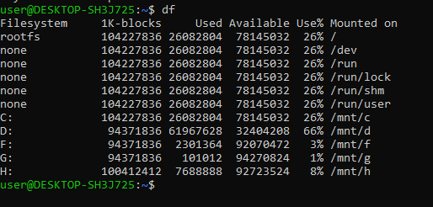

6.du: du specified the space used by file and folders.



7.mkdir: The mkdir command means to make new empty directory. When it used, this command will make a directory in the present working directory.

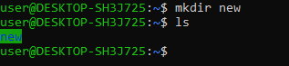

8.passwd: passwd is a text file that contains the attributes of each user or account on a computer running Linux or another Unix-like operating system.

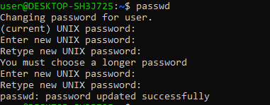

9.rm: rm stands for remove. It tries to remove the files specified on the command line. Use the rm command to delete files and directories on Ubuntu Linux.



10.ln: ln means ln command that is used for linking files and directories to each other. ln command allows any number of new names to be created, all pointing to the same file or directory.



11.cal: cal is a command-line calendar to Linux and UNIX. It displays a simple calendar in text format.

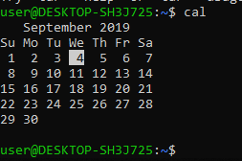

12.echo: echo command in linux is used to display line of text/string that are passed as an argument. Echo is often used in shell scripts to display information such as asking for user to provide an input or displaying the error or warning for a certain action in the script.



13.tty: The tty command will print the name of the device file that your pseudo-teletype slave is using to interface to the master. And that, effectively, is the number of your terminal window.



14.date: date command is used to display the system date and time. date command is also used to set date and time of the system.



15.free: The free command gives information about used and unused memory usage and swap memory of a system. It displays memory in kb(kilobytes)

